Docker Task 03

- Create an image from running container.

Step 1: Pull NGINX image
docker pull nginx:latest
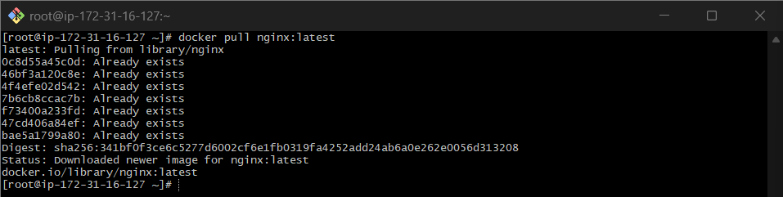
Step 2: Run NGINX container
docker container run -itd -p 8080:80 --name nginx-container nginx:latest
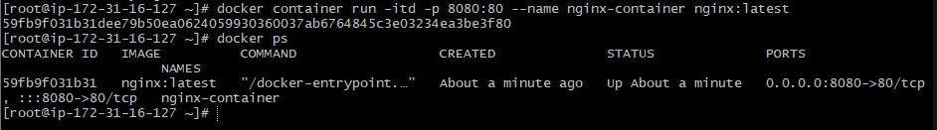

Step 3: Enter running container
docker exec -it nginx-container /bin/sh

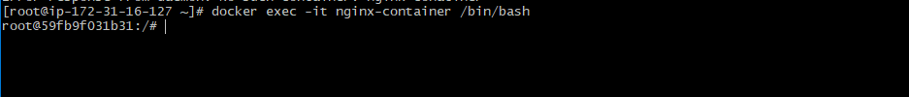

Step 4: Modify NGINX default page
echo "<h1>NGINX Image Created from Running Container</h1>" > /usr/share/nginx/html/index.html
exit
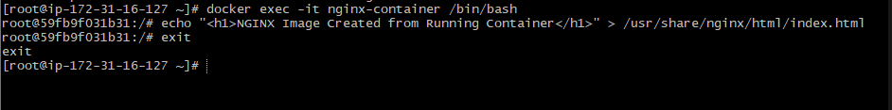

Step 5: Create image from container
docker commit nginx-container custom-nginx:v1

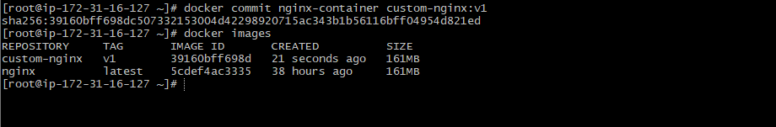

Step 6: Verify image
docker images

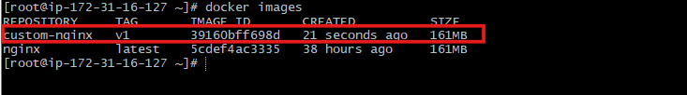

Validation: http://54.163.206.35:8080/

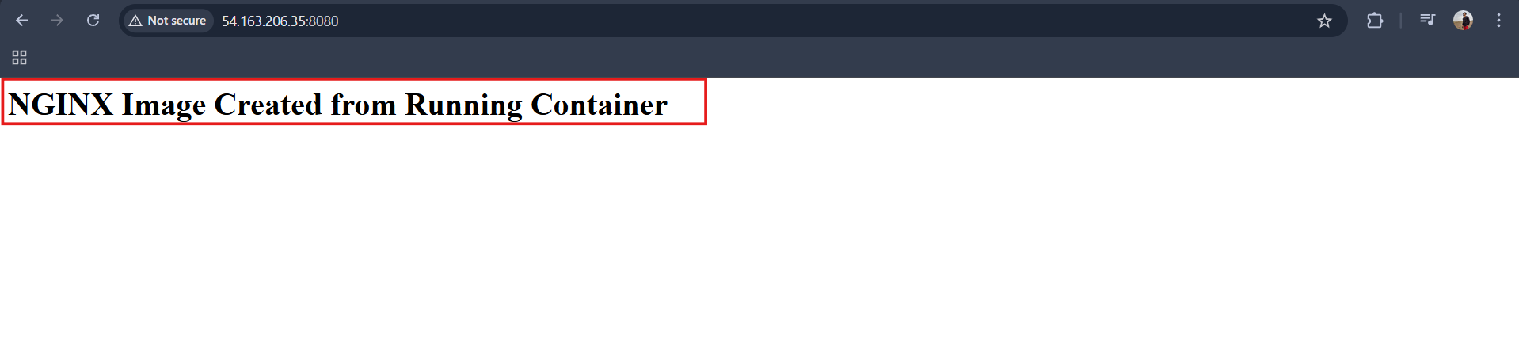

- Copy image from local machine to docker server and load the image.

Open gitbash in desktop
Then pull image here (Make sure u have signed in to uer desktop docker account )
docker pull nginx

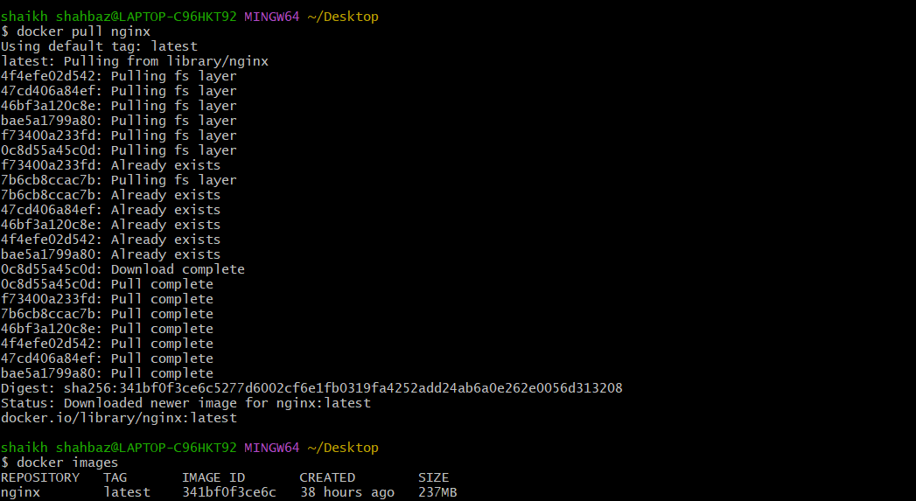

Step 1: Save Docker image
docker save -o nginx.tar nginx:latest
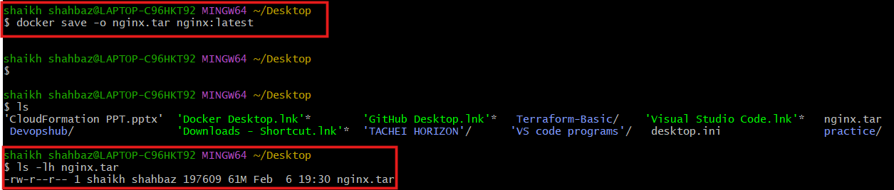

Step 2: Copy image to Docker server
scp -i "/c/Users/shaikh shahbaz/Downloads/docker.pem" \
"/c/Users/shaikh shahbaz/Desktop/nginx.tar" \
ec2-user@54.163.206.35:/tmp/

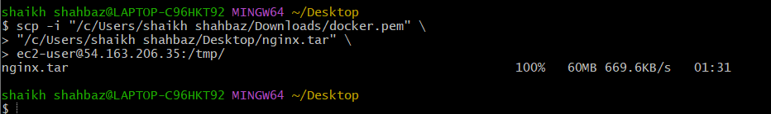

Step 3: Login to Docker server
ssh -i "docker.pem" ec2-user@ec2-54-163-206-35.compute-1.amazonaws.com

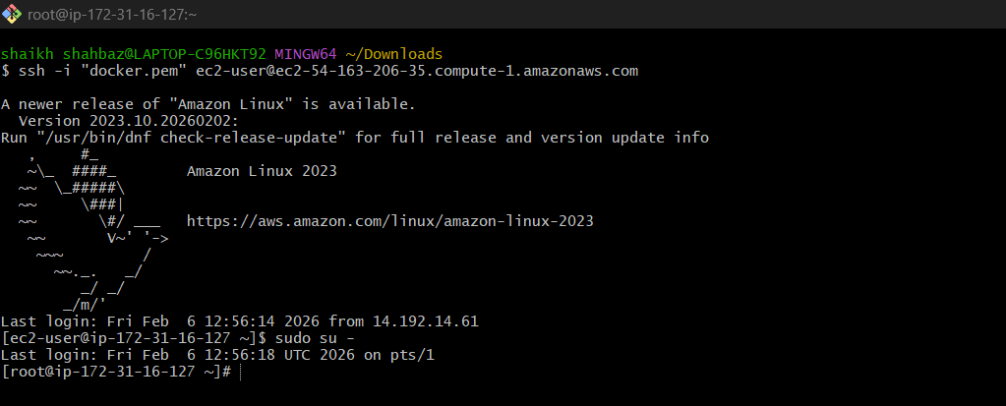
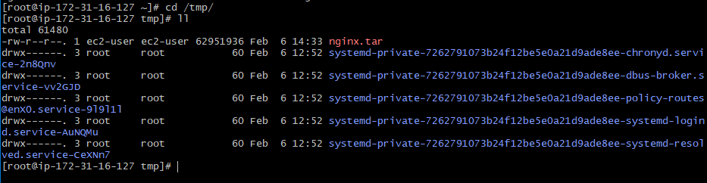

Step 4: Load image on Docker server
docker load -i /tmp/nginx.tar

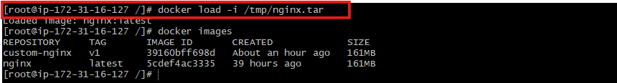

Step 5: Verify image
docker images
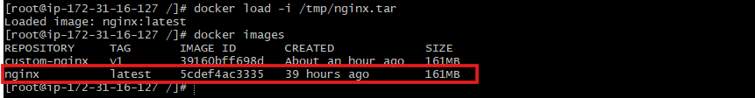

- Create Docker image using alpine and customize with tomcat.

Step 1: Create Dockerfile
vi Dockerfile

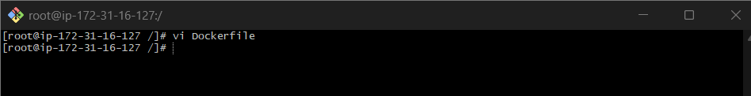

Step 2: Add content

# ---------- BUILD STAGE ----------
FROM maven:3.9.6-eclipse-temurin-17 AS builder
WORKDIR /app
COPY pom.xml .
RUN mvn dependency:go-offline
COPY src ./src
RUN mvn clean package -DskipTests

# ---------- RUNTIME STAGE ----------
FROM eclipse-temurin:17-jre
WORKDIR /app
COPY --from=builder /app/target/*.jar app.jar
EXPOSE 8080
CMD ["java","-jar","app.jar"]

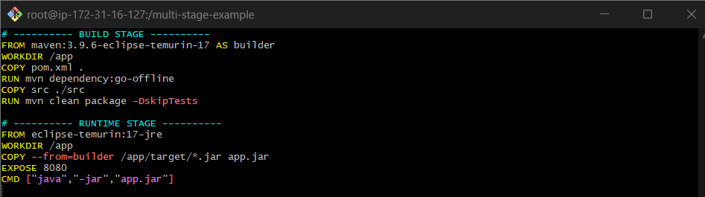

Step 3: Build image
docker build -t alpine-tomcat .

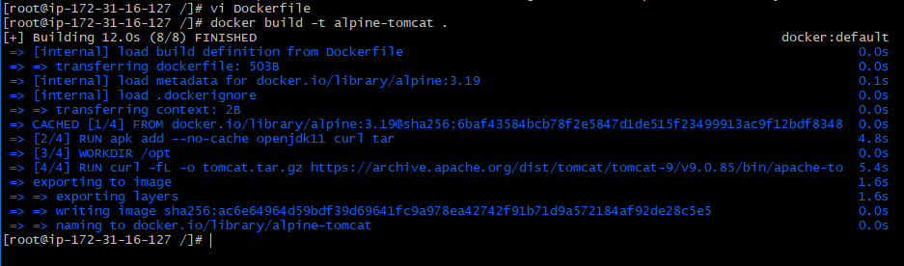

Step 4: Run container
docker run -itd -p 9090:8080 --name alpine-tomcat alpine-tomcat
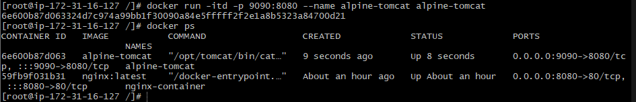

Validation: http://54.163.206.35:9090/

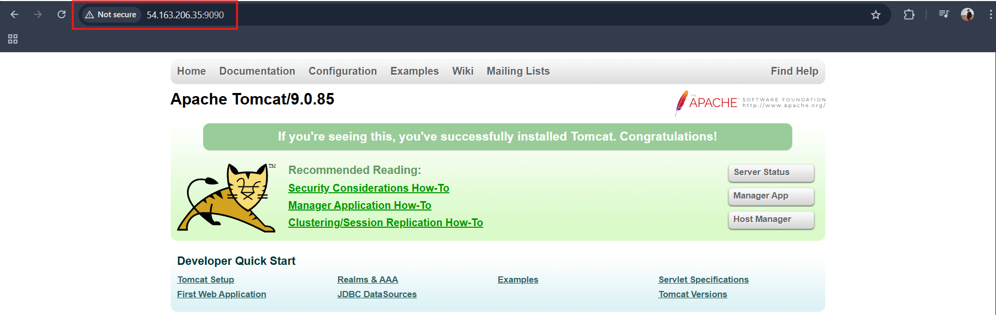

- Create single stage and multi stage docker file using this source code: https://github.com/betawins/multi-stage-example.git

Step 1: Clone repository
git clone https://github.com/betawins/multi-stage-example.git

cd multi-stage-example

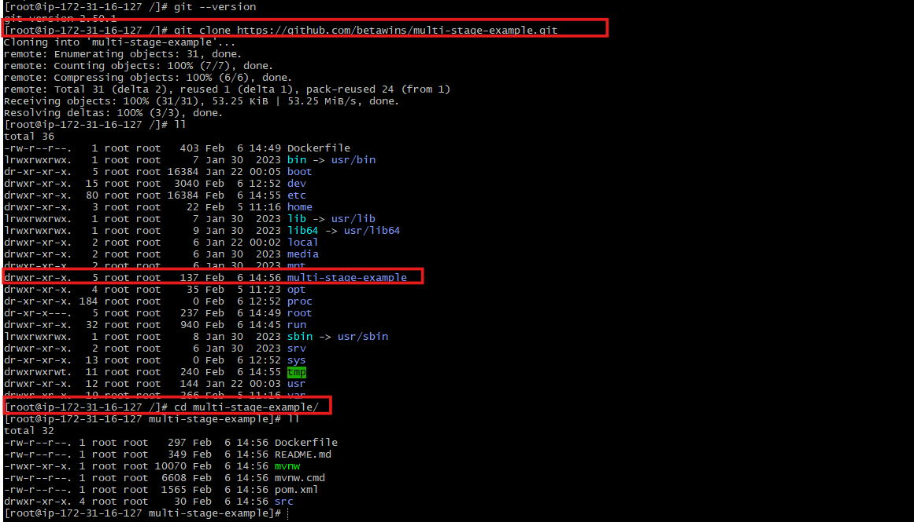

Single-Stage Dockerfile

Step 2: Create Dockerfile
vi Dockerfile.single

Step 3: Add content
FROM maven:3.9.6-eclipse-temurin-17

WORKDIR /app

COPY . .

RUN mvn clean package -DskipTests

EXPOSE 8080

CMD ["java","-jar","target/multi-stage-example-0.0.1-SNAPSHOT.jar"]

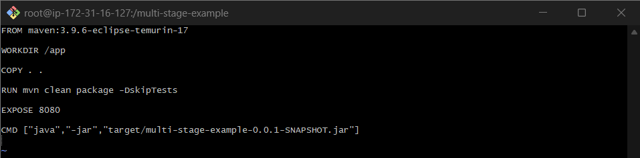

Build single-stage image
docker build -f Dockerfile-single -t single-stage-app .

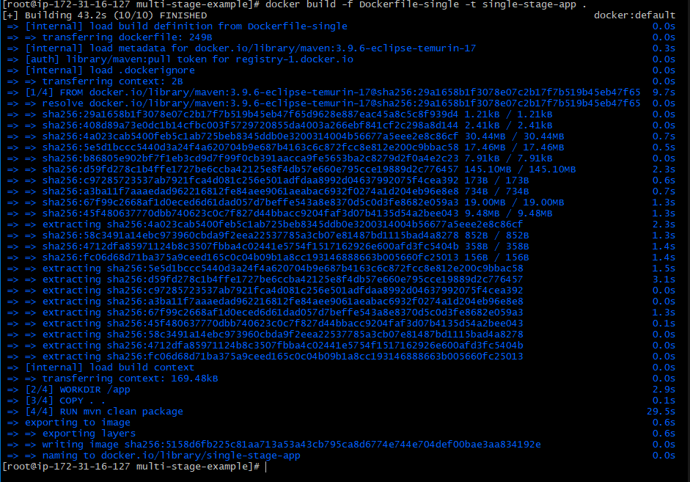

Run single-stage container
docker run -d -p 8081:8080 --name single-stage single-stage-app

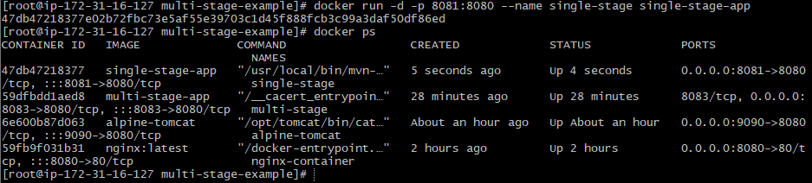

Validation: http://54.163.206.35:8081/
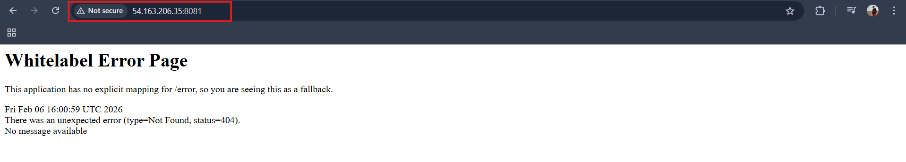

Multi-Stage Dockerfile

Step 4: Create Dockerfile
vi Dockerfile.multi

Step 5: Add content
# =========================
# BUILD STAGE
# =========================
FROM maven:3.9.6-eclipse-temurin-17 AS builder

WORKDIR /app

# Copy pom first to cache dependencies
COPY pom.xml .
RUN mvn dependency:go-offline

# Copy source code
COPY src ./src

# Build the application
RUN mvn clean package -DskipTests

# =========================
# RUNTIME STAGE
# =========================
FROM eclipse-temurin:17-jre-alpine

WORKDIR /app

# Copy jar from builder stage
COPY --from=builder /app/target/*.jar app.jar

# Expose application port
EXPOSE 8083

# Run the application
CMD ["java","-jar","app.jar"]

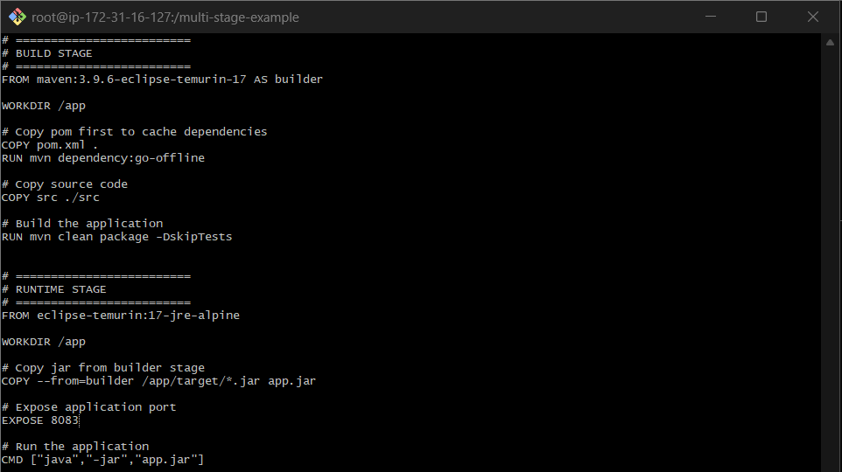

Build multi-stage image
docker build -f Dockerfile-multi -t multi-stage-app .

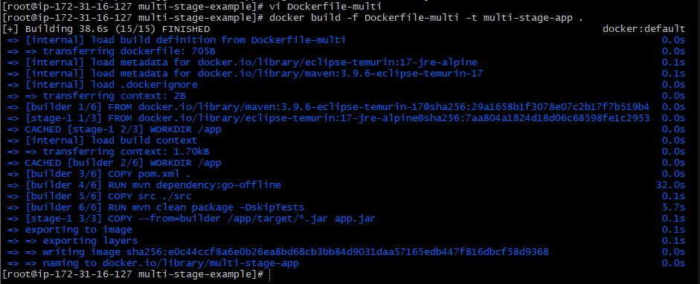

Run Container
docker run -d -p 8083:8080 --name multi-stage multi-stage-app

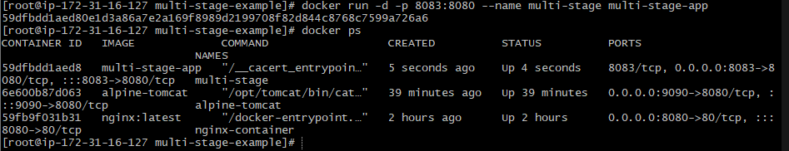

Validation: http://54.163.206.35:8083/

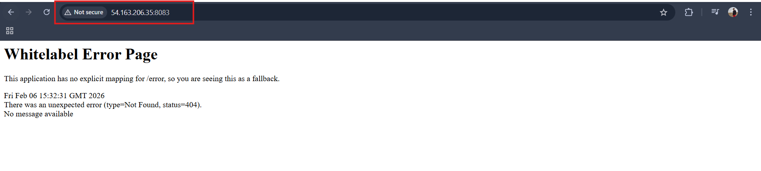

- Install docker compose and execute sample application.

Step 1: Install Docker Compose

sudo curl -L https://github.com/docker/compose/releases/latest/download/docker-compose-linux-x86_64 \
-o /usr/local/bin/docker-compose
sudo chmod +x /usr/local/bin/docker-compose

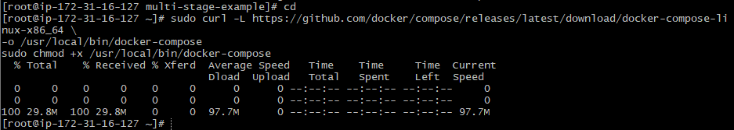

Step 2: Verify installation
docker-compose version

Step 3: Create docker-compose.yml
vi docker-compose.yml

Step 4: Add content
version: "5.0.2"
services:
web:
image: nginx
ports:
- "8085:80"

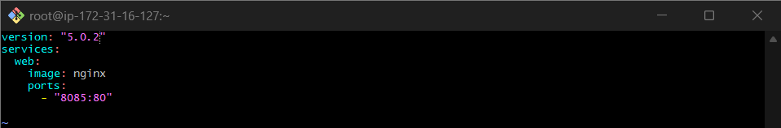

Step 5: Run application
docker-compose up -d

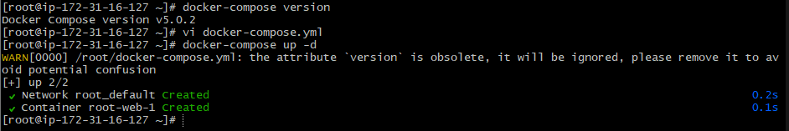

docker ps

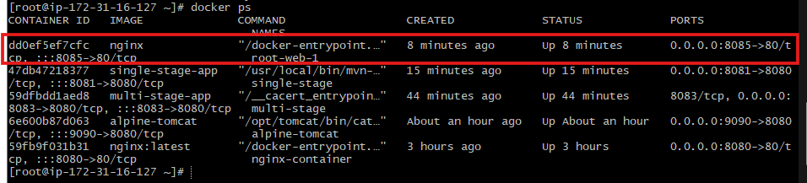

Validation: http://54.163.206.35:8085/

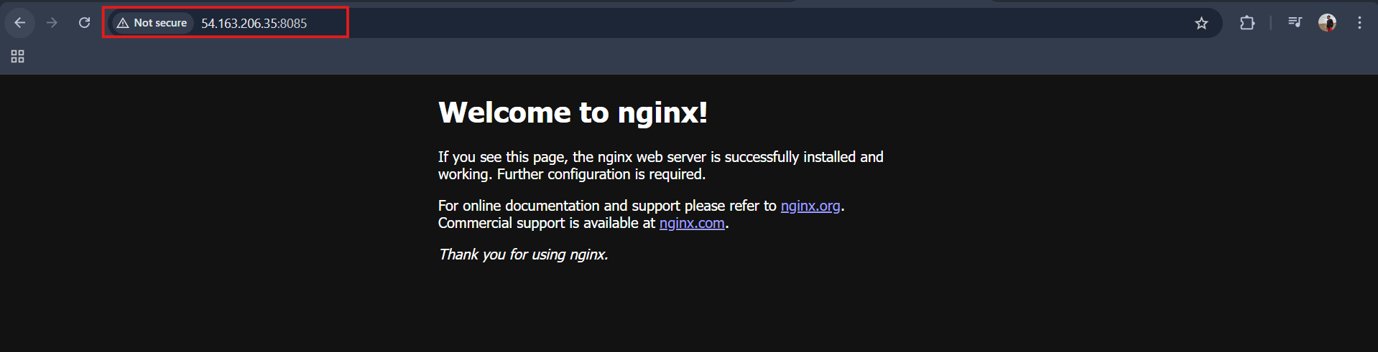

- Implement solution to scan images when pushed to docker registry.

Goto docker hub Repositories
Navigate to settings tab and enable Docker Scout image analysis
Click Save

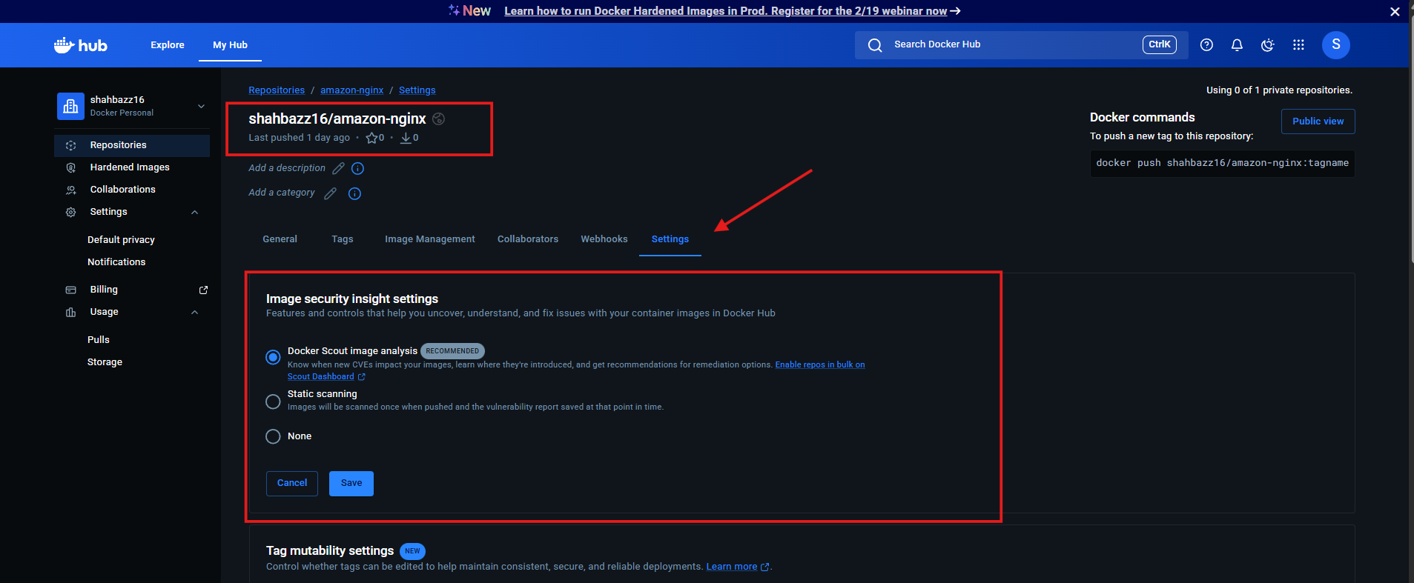

Step 1:
Docker login

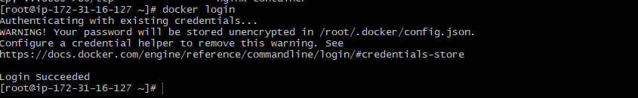
Step:2
Create a tag of image
docker tag multi-stage:v1 shahbazz16/amazon-nginx:1.0 .

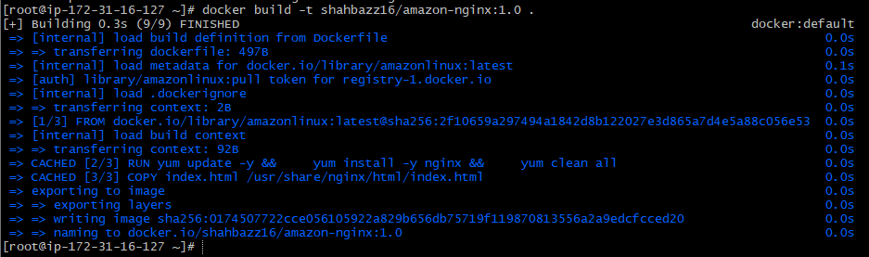

Build Image with Docker Hub
docker build -t shahbazz16/amazon-nginx:1.0 .

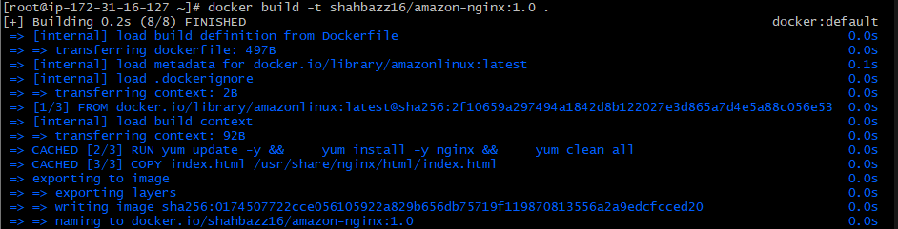
Step:3
Push that tag image to your docker gui

Download Trivy binary (latest stable)
wget https://github.com/aquasecurity/trivy/releases/download/v0.69.1/trivy_0.69.1_Linux-64bit.tar.gz

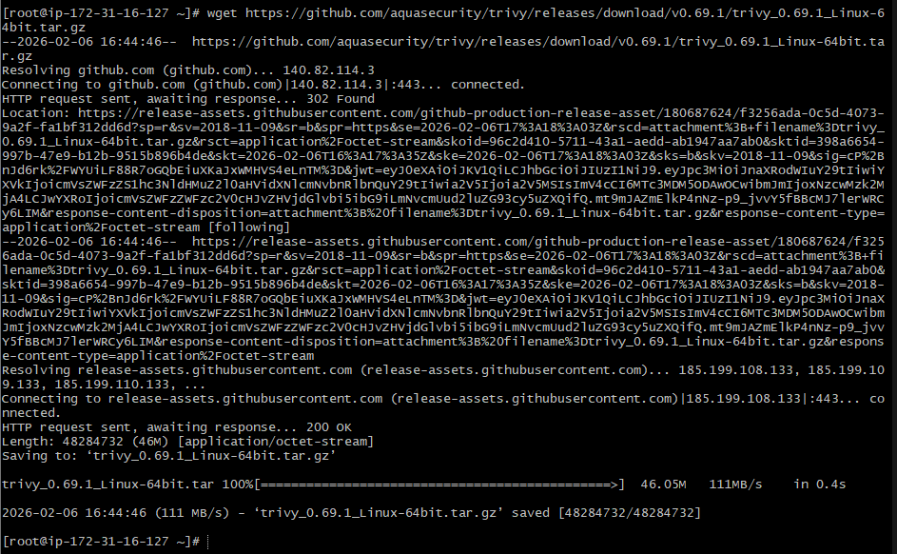

Extract it
tar -xvf trivy_0.69.1_Linux-64bit.tar.gz

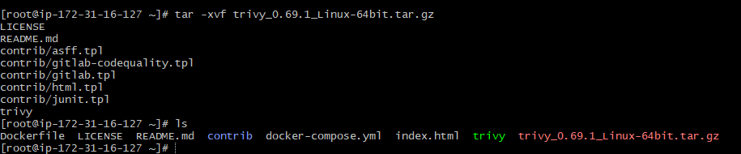
Move binary
sudo mv trivy /usr/local/bin/
sudo chmod +x /usr/local/bin/trivy

Verify installation
trivy --version

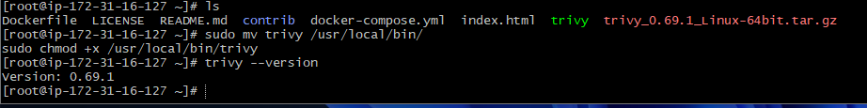

Now scan your Docker image
trivy image --severity HIGH,CRITICAL --exit-code 1 shahbazz16/amazon-nginx:1.0

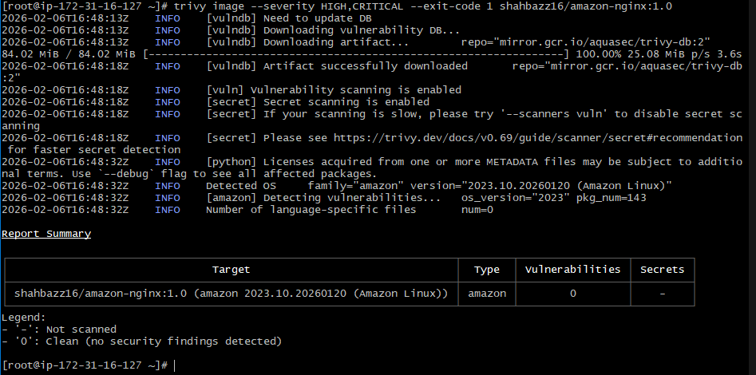

Push only if scan passes
docker push shahbazz16/amazon-nginx:1.0

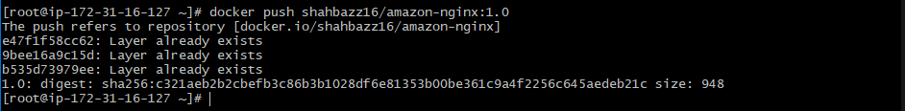

Step:4
Now check your docker gui —> repository—> images

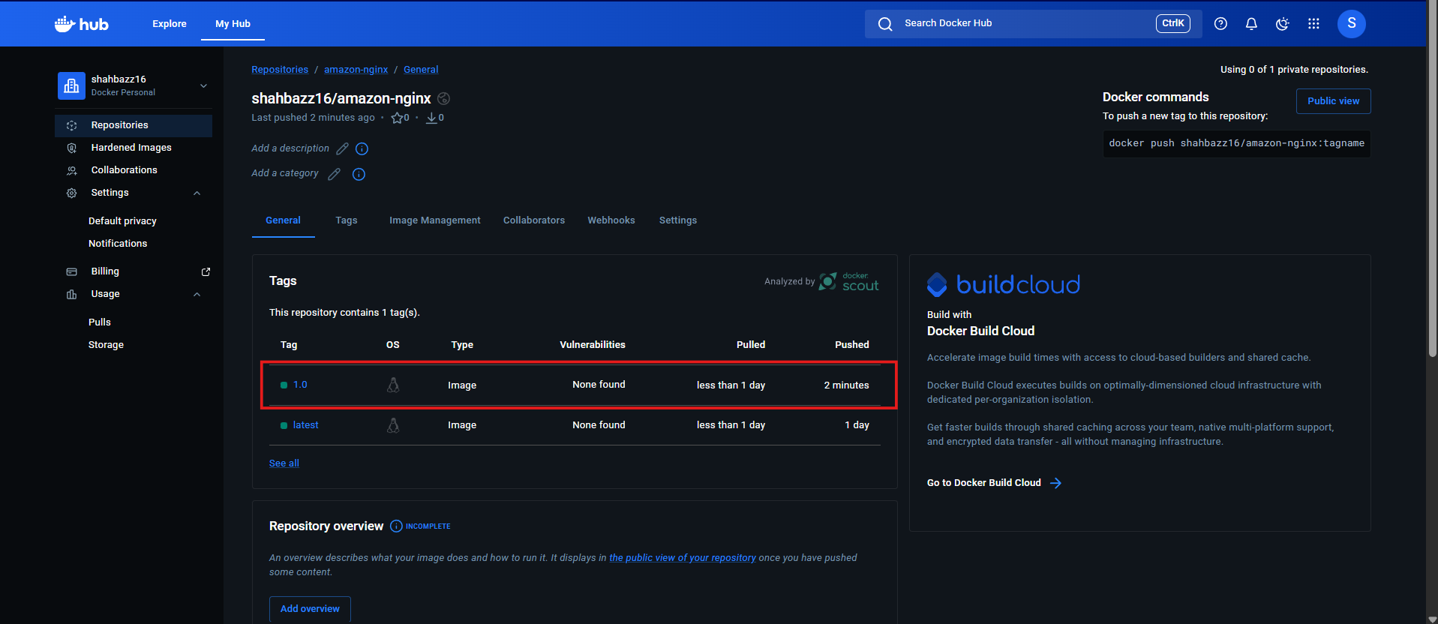

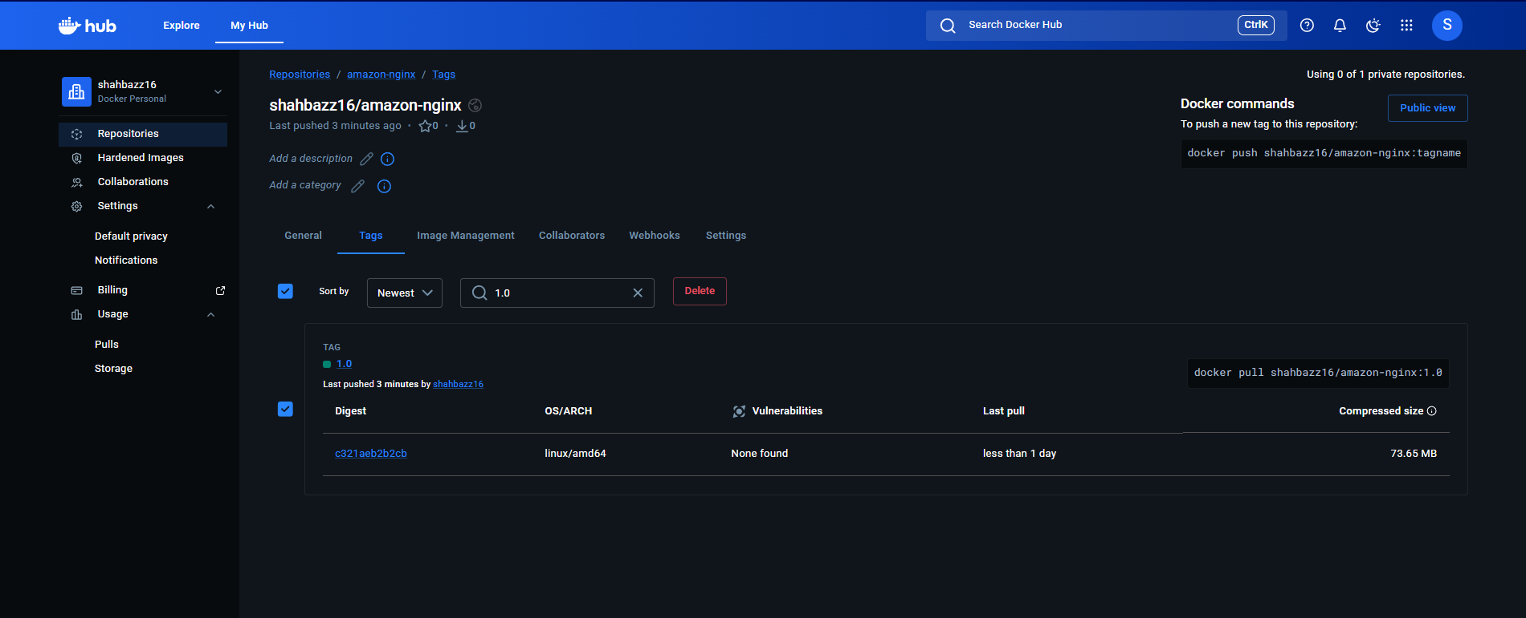

- Implement solution to scan images when pushed to AWS ECR.

Step 1: Enable scan on push

aws ecr describe-repositories \
--repository-names amazon-nginx \
--region us-east-1

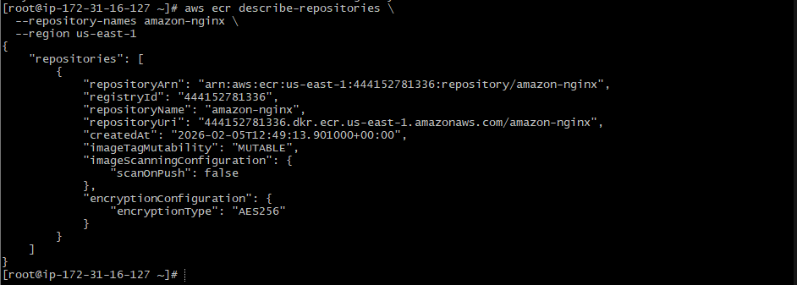

Step 2: Enable image scanning on push (IMPORTANT)
aws ecr put-image-scanning-configuration \
--repository-name amazon-nginx \
--image-scanning-configuration scanOnPush=true \
--region us-east-1

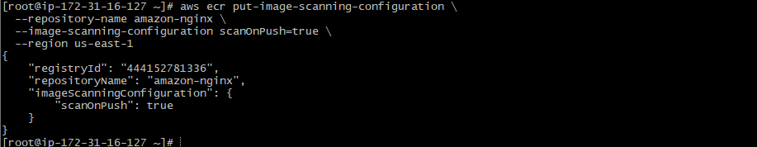

Step 3: Login to ECR
aws ecr get-login-password --region us-east-1 \
| docker login --username AWS --password-stdin \
444152781336.dkr.ecr.us-east-1.amazonaws.com

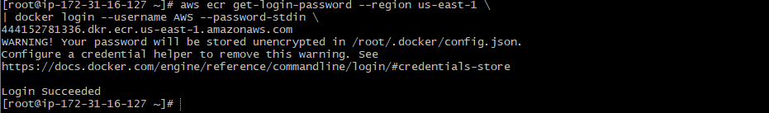

Step 5: Tag the existing image for ECR

docker tag multi-stage-app:latest \
444152781336.dkr.ecr.us-east-1.amazonaws.com/amazon-nginx:latest
docker images

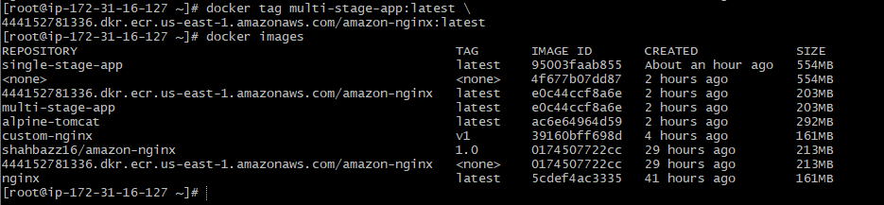

Push image to ECR
docker push 444152781336.dkr.ecr.us-east-1.amazonaws.com/amazon-nginx:latest

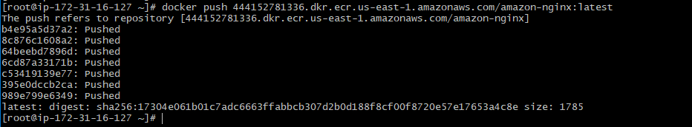

Check in AWS Console
Path:
AWS Console → ECR → my-ecr-repo → Images → Scan findings

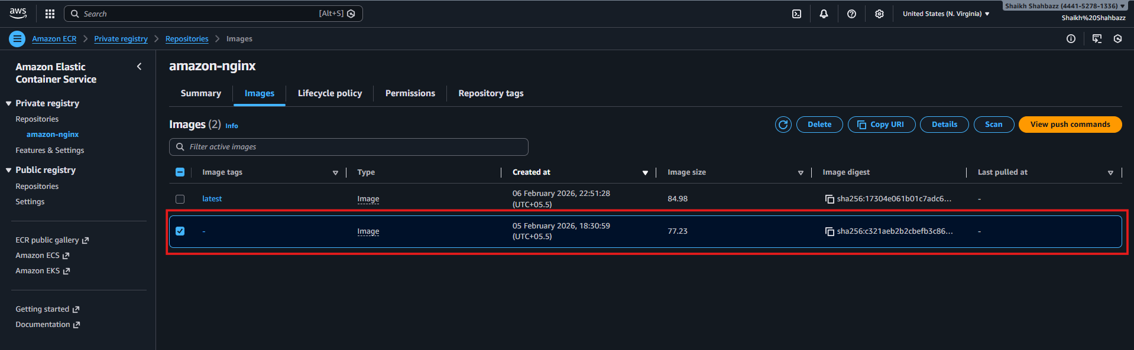

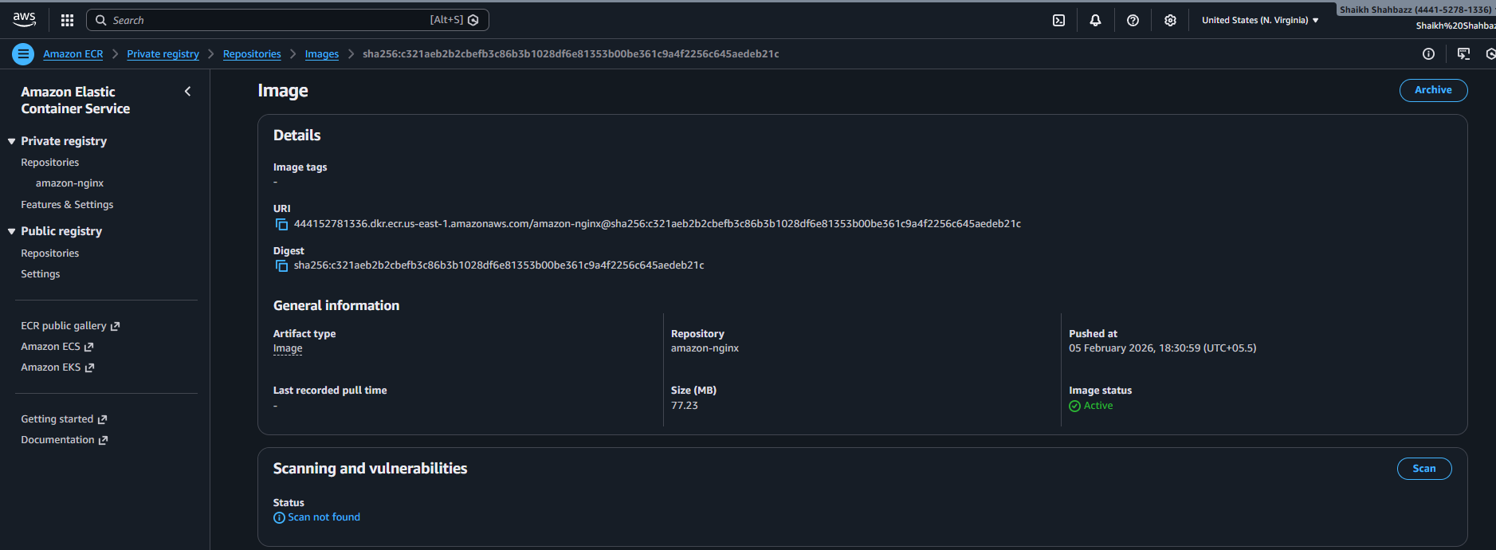

- Create a Jenkins pipeline to create a docker image and push the image to Docker hub.

Login to your Jenkins server gui
Make sure you have
docker—version
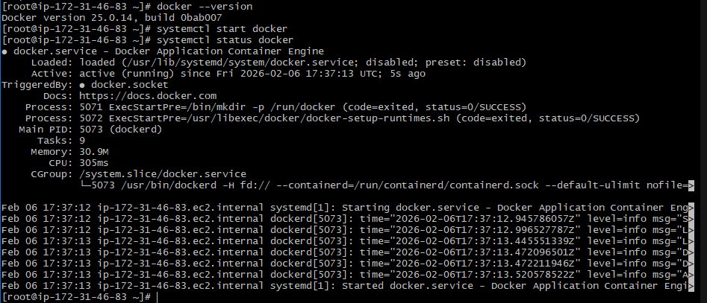

Step2:
Install plugins
make sure the docker is available in that server

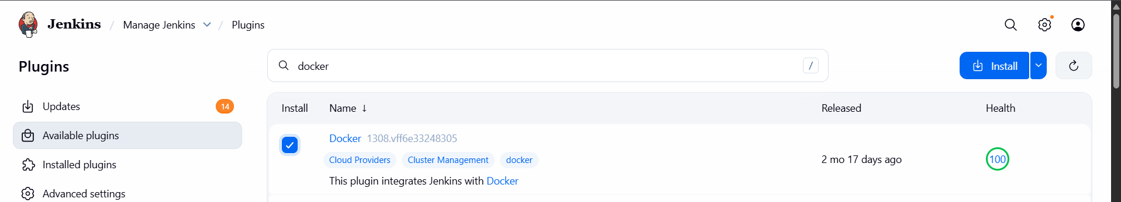
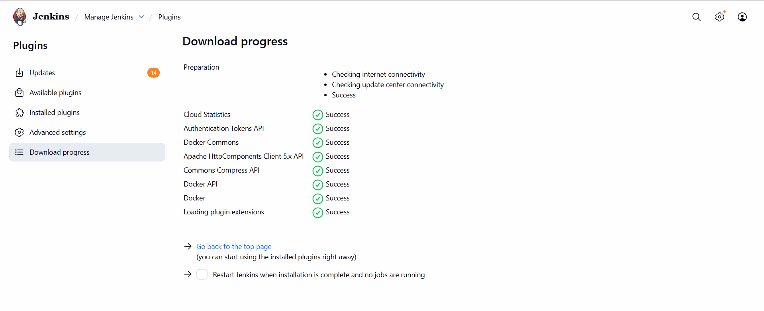
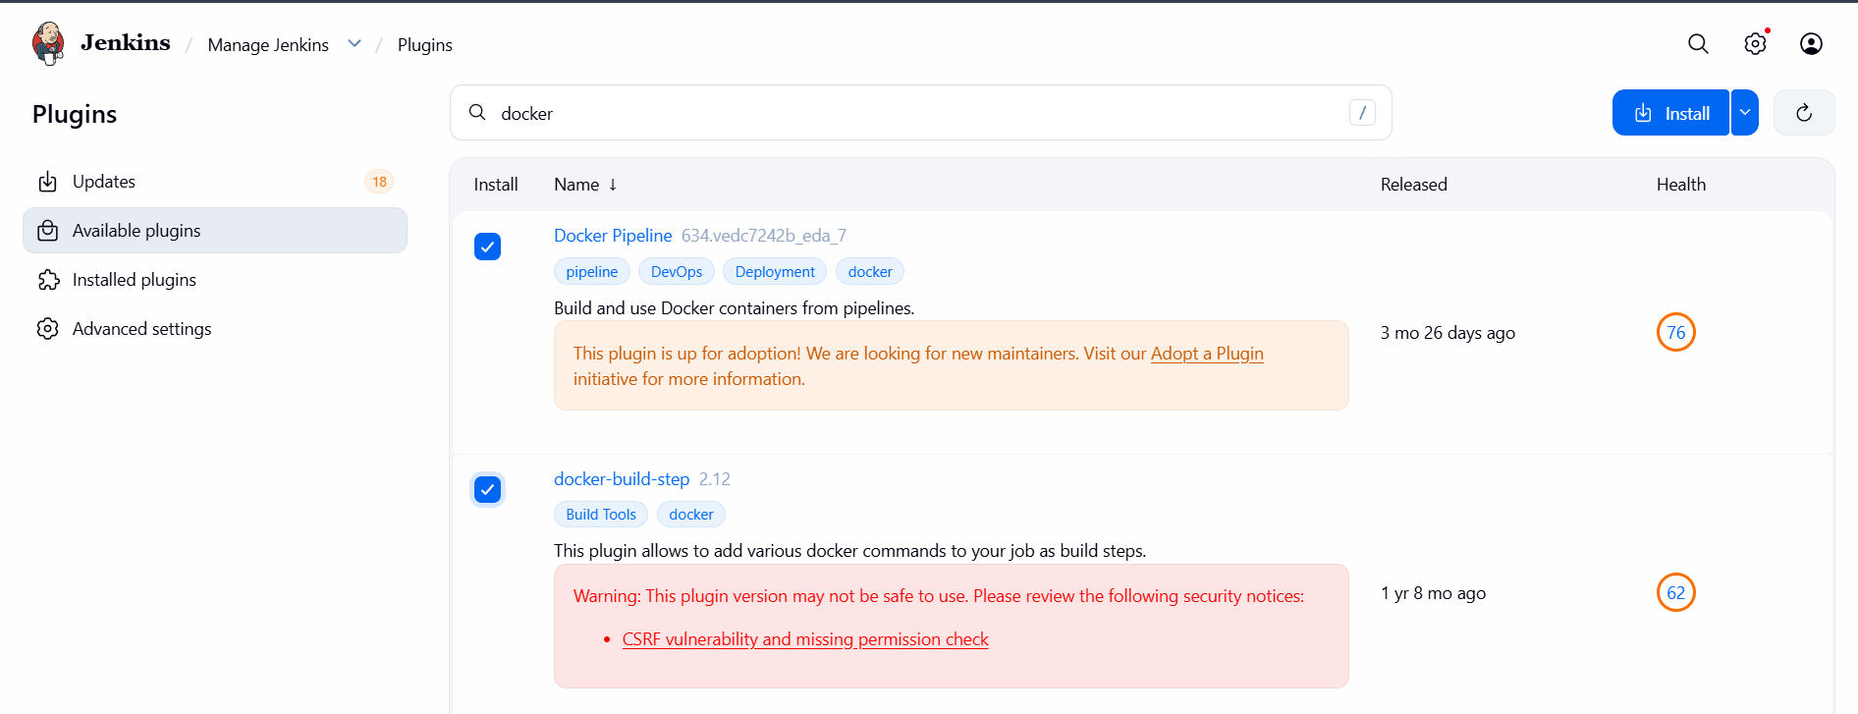

Step3: Create credentials of docker hub username password

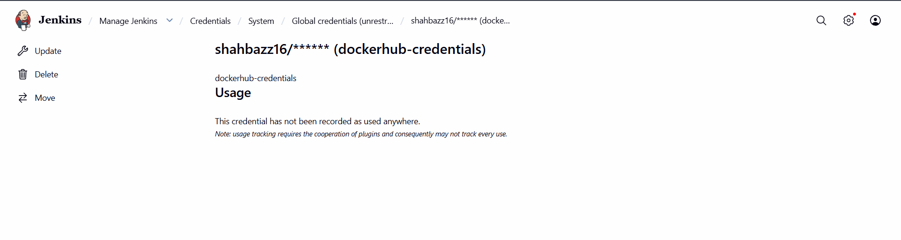

Step3:
Create a repo

- Created new repo : docker-pipeline

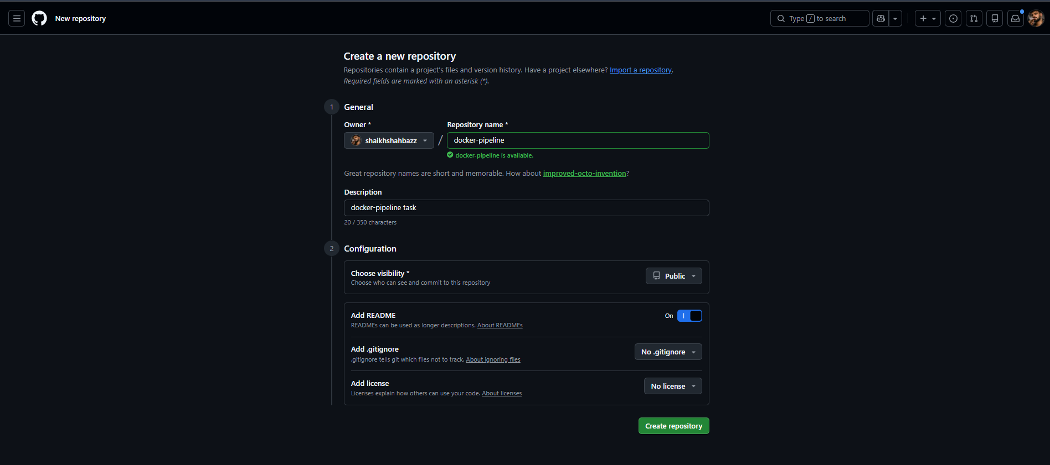

- Add:
docker-pipeline/
├── Jenkinsfile
├── Dockerfile
└── index.html

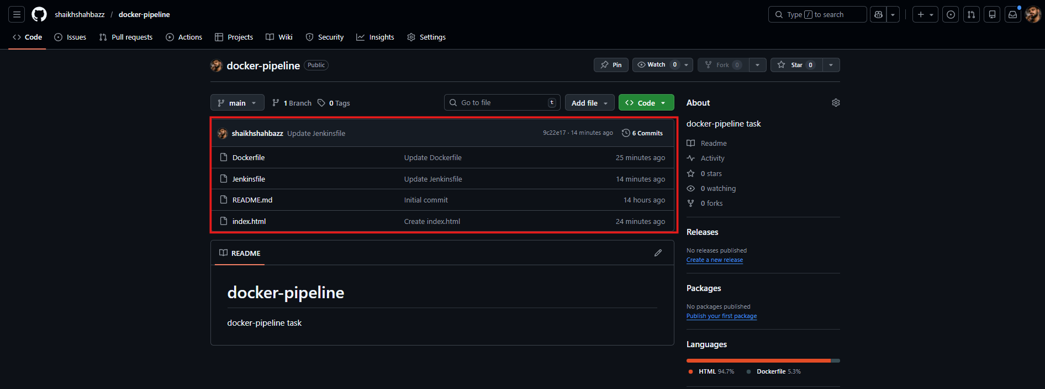

- Jenkinsfile

pipeline {
agent any

environment {
DOCKER_IMAGE = "shahbazz16/amazon-nginx"
DOCKER_TAG = "latest"
}

stages {

stage('Checkout Code') {
steps {
git 'https://github.com/shaikhshahbazz/docker-pipeline.git'
}
}

stage('Build Docker Image') {
steps {
script {
docker.build("${DOCKER_IMAGE}:${DOCKER_TAG}")
}
}
}

stage('Login to Docker Hub') {
steps {
withCredentials([usernamePassword(
credentialsId: 'dockerhub-creds',
usernameVariable: 'DOCKER_USER',
passwordVariable: 'DOCKER_PASS'
)]) {
sh 'echo $DOCKER_PASS | docker login -u $DOCKER_USER --password-stdin'
}
}
}

stage('Push Docker Image') {
steps {
script {
docker.image("${DOCKER_IMAGE}:${DOCKER_TAG}").push()
}
}
}
}

post {
always {
sh 'docker logout'
}
success {
echo 'Docker image built and pushed successfully 🎉'
}
failure {
echo 'Pipeline failed ❌'
}
}
}

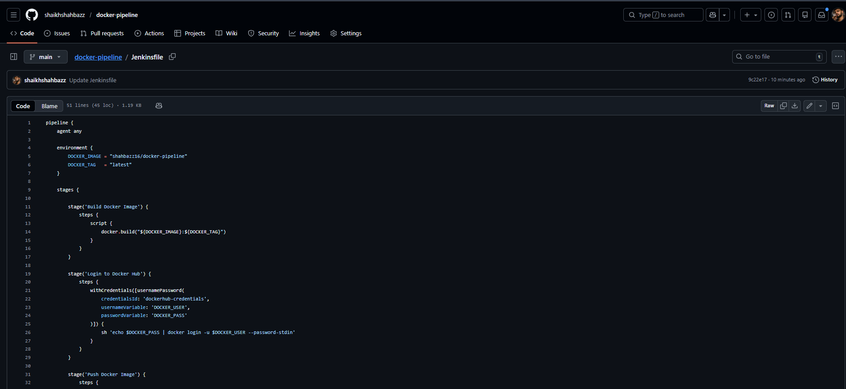

- Dockerfile

FROM nginx:alpine
COPY index.html /usr/share/nginx/html/index.html
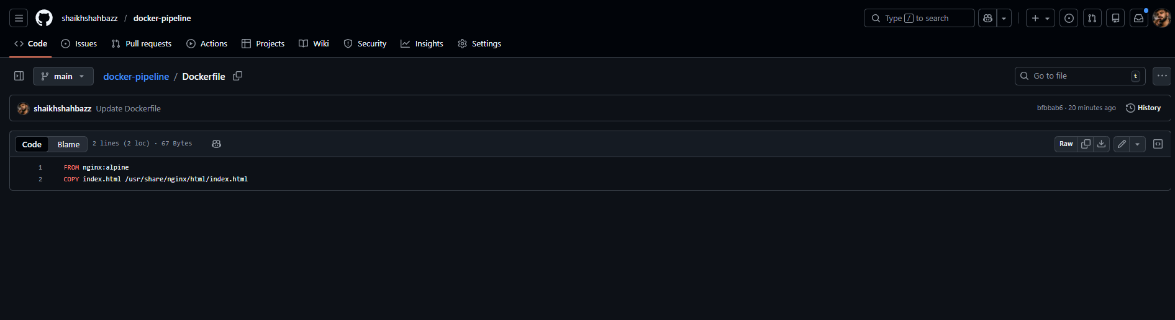

- index.html

<!DOCTYPE html>
<html lang="en">
<head>
<meta charset="UTF-8">
<title>Jenkins Docker Pipeline</title>
<meta name="viewport" content="width=device-width, initial-scale=1.0">
<style>
body {
font-family: Arial, sans-serif;
background: #0f172a;
color: #e5e7eb;
display: flex;
align-items: center;
justify-content: center;
height: 100vh;
margin: 0;
}
.container {
text-align: center;
padding: 40px;
background: #020617;
border-radius: 10px;
box-shadow: 0 10px 30px rgba(0,0,0,0.5);
}
h1 {
color: #38bdf8;
}
p {
font-size: 1.1rem;
}
footer {
margin-top: 20px;
font-size: 0.9rem;
color: #94a3b8;
}
</style>
</head>
<body>

<div class="container">
<h1>🚀 Jenkins + Docker</h1>
<p>Docker image built and pushed to Docker Hub successfully!</p>
<p>This app was deployed using a Jenkins Pipeline.</p>
<footer>
<p>CI/CD in action 🔥</p>
</footer>
</div>

</body>
</html>

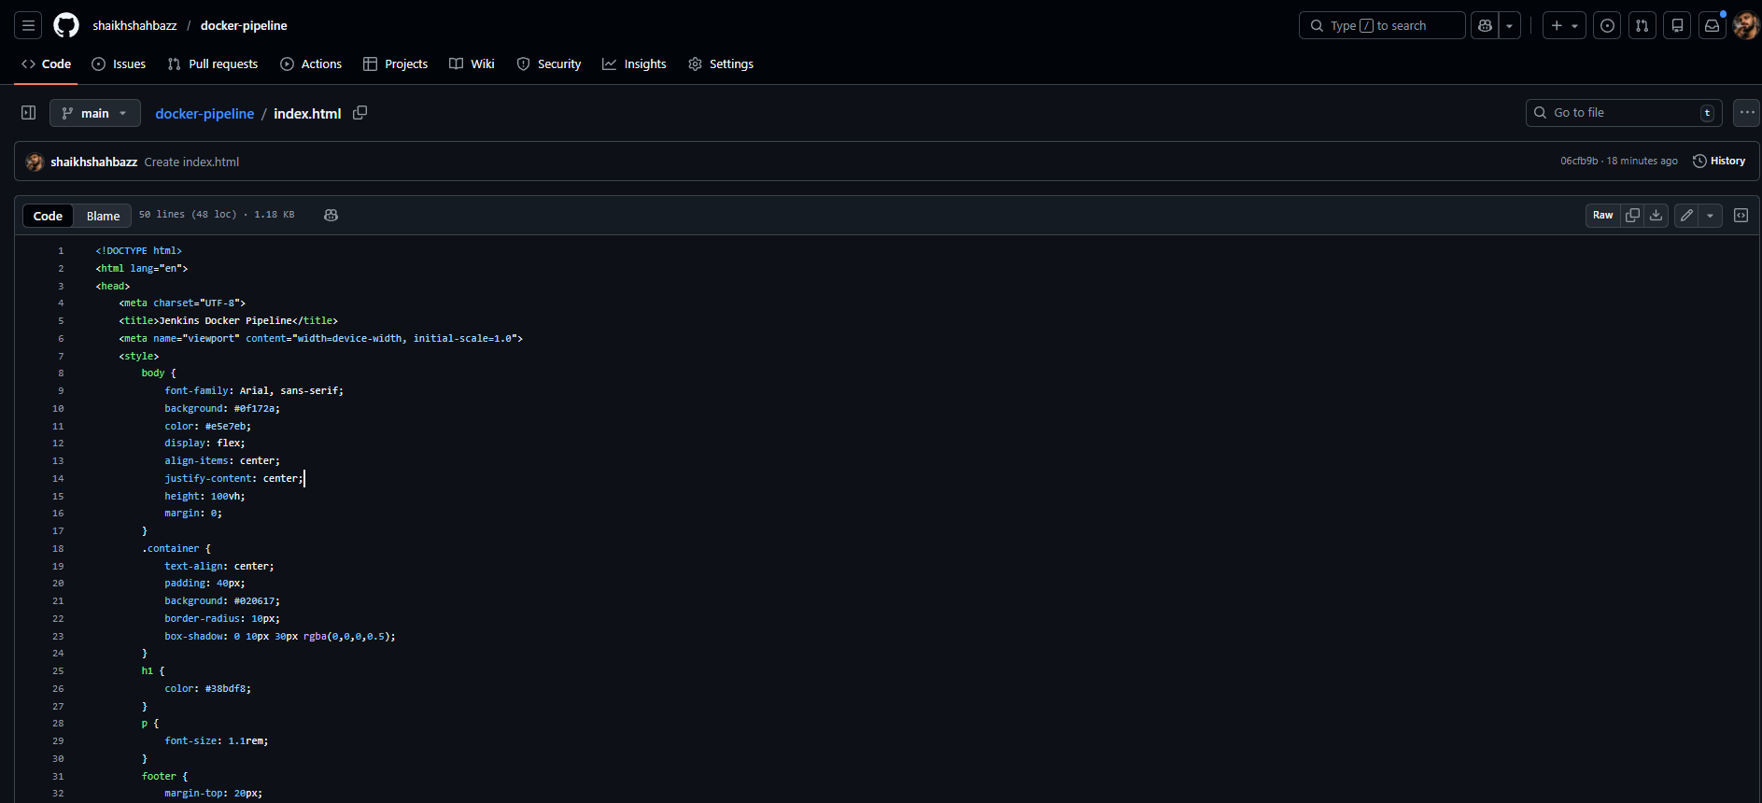

Create Pipeline
New Item → Pipeline → Name: docker-pipeline
—-> attach the repo url
Save

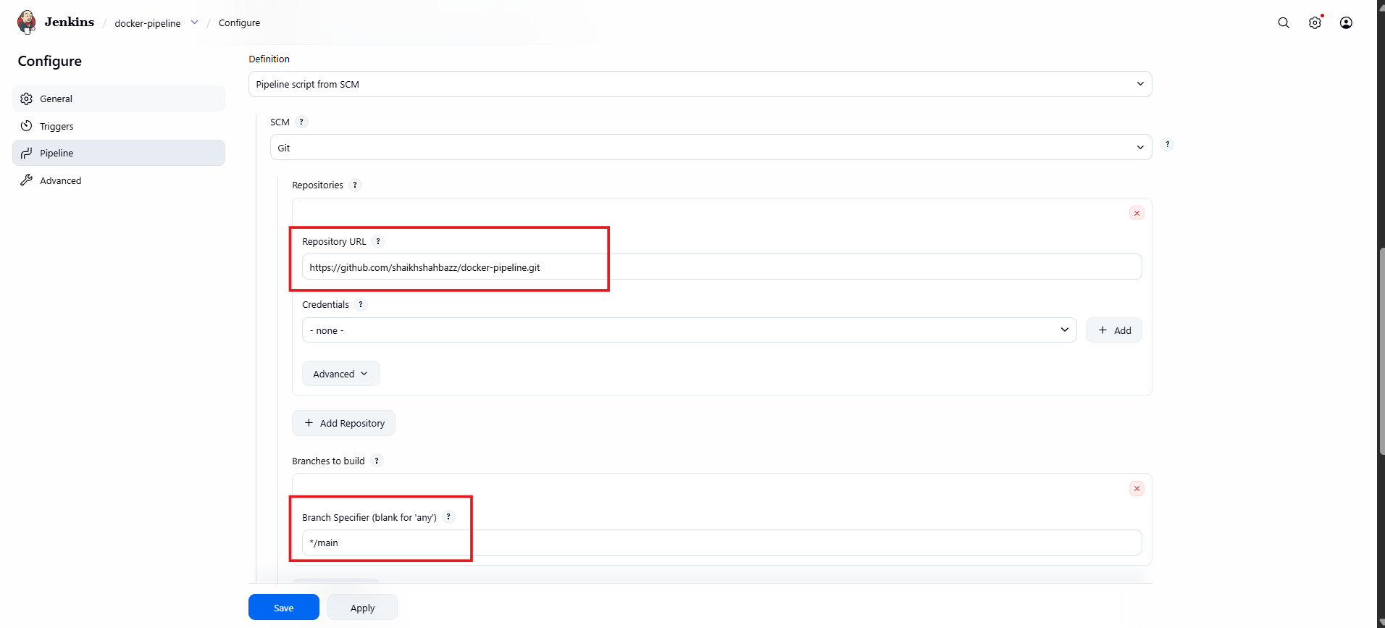

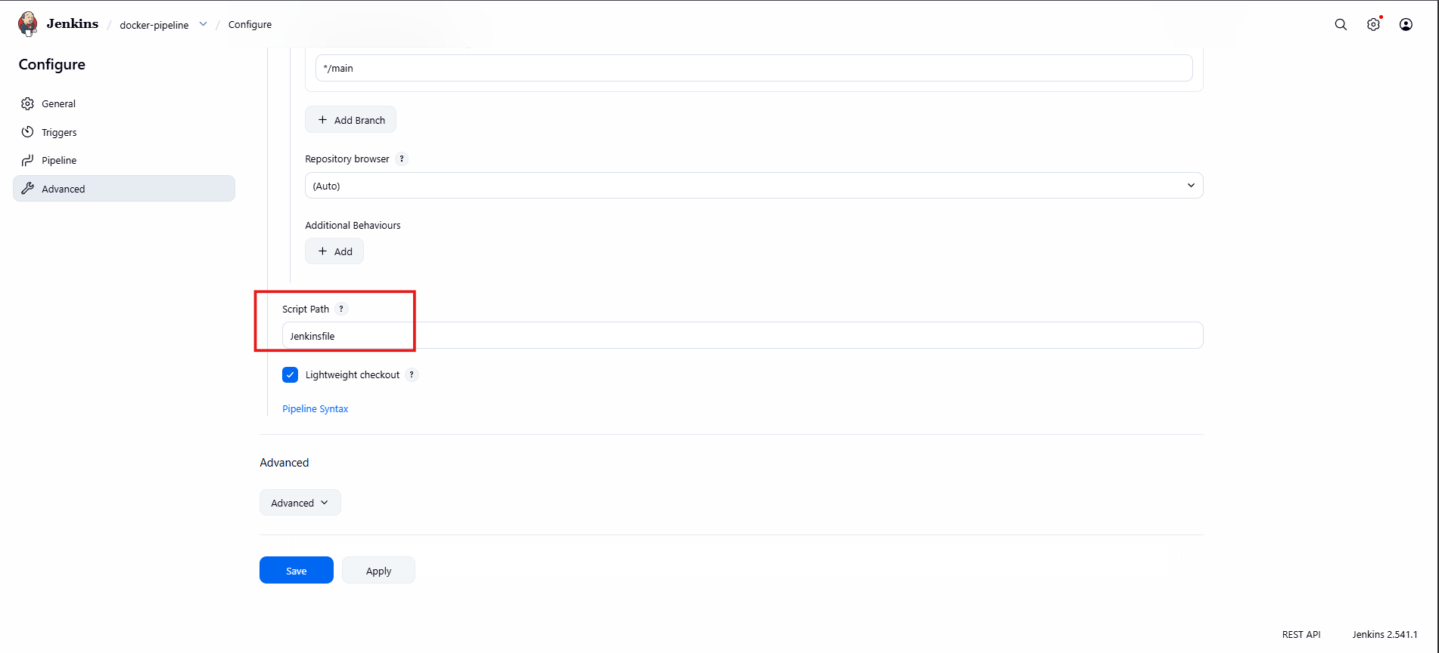

Now build run

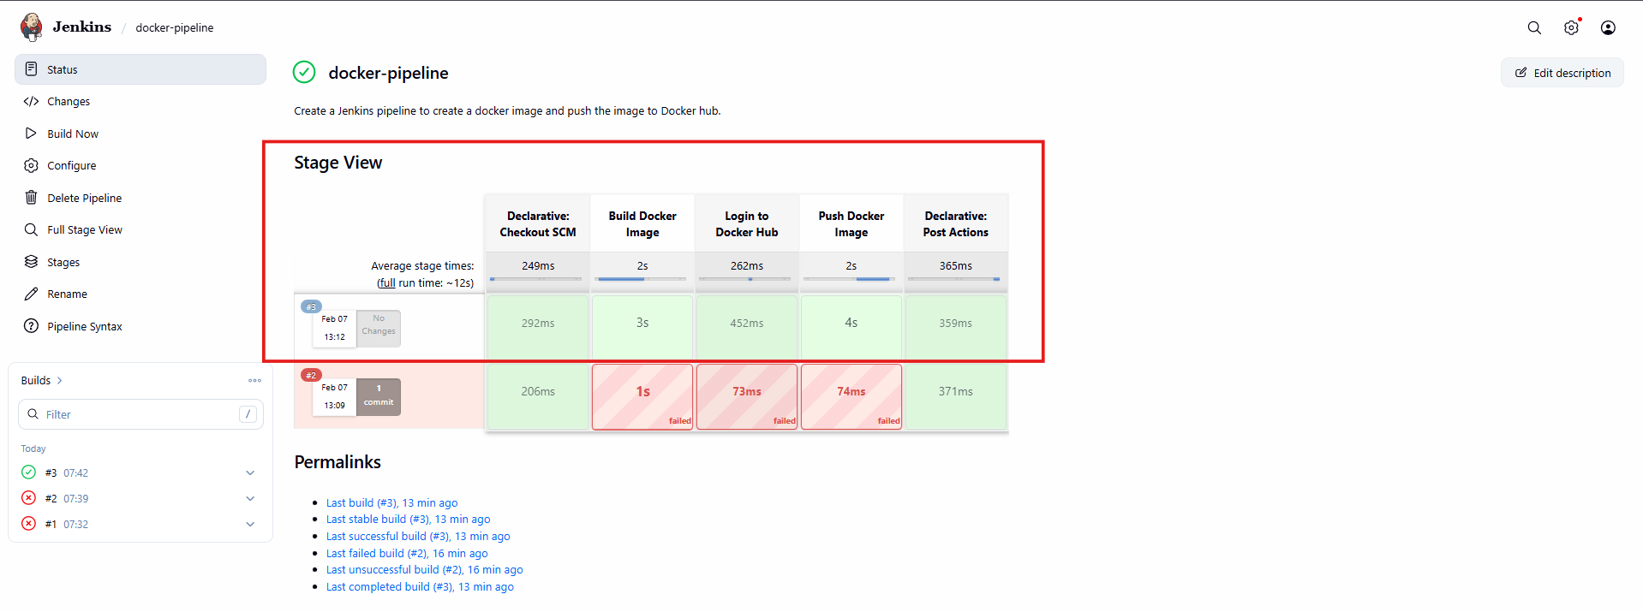

- Pipeline Overview:

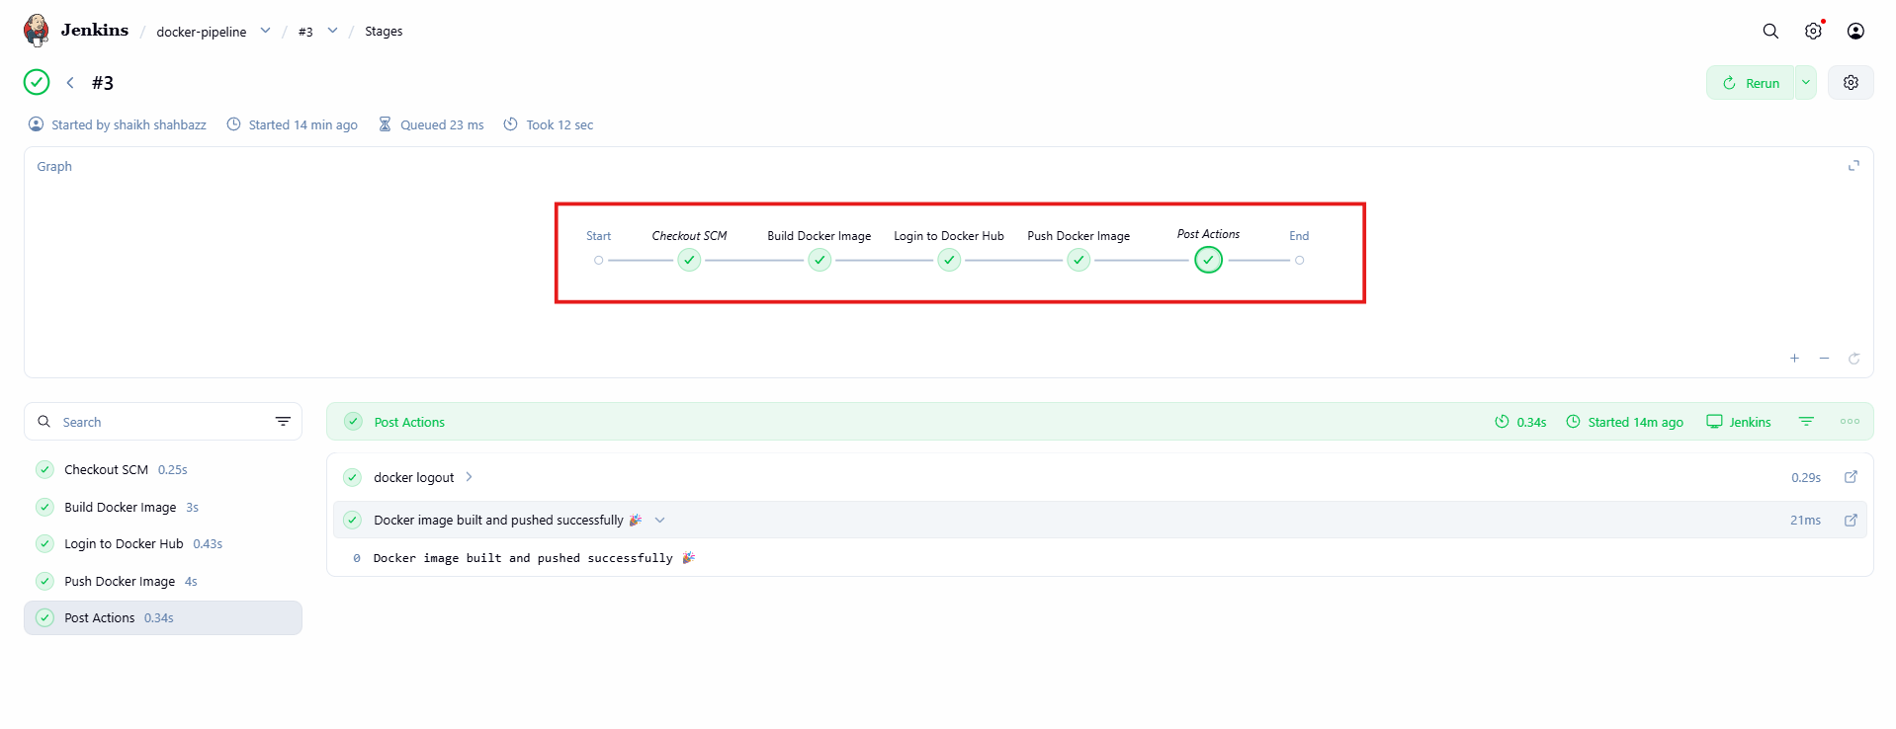

Validation:

- check your docker hub
- we can see we created shahbazz16/docker-pipeline

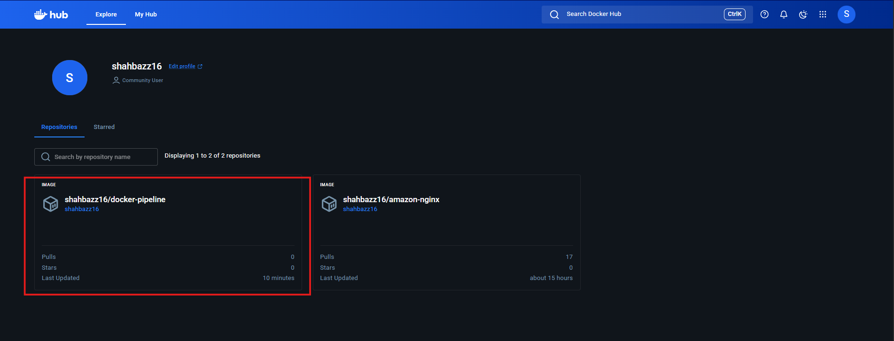

- Naviagate to Tags tab

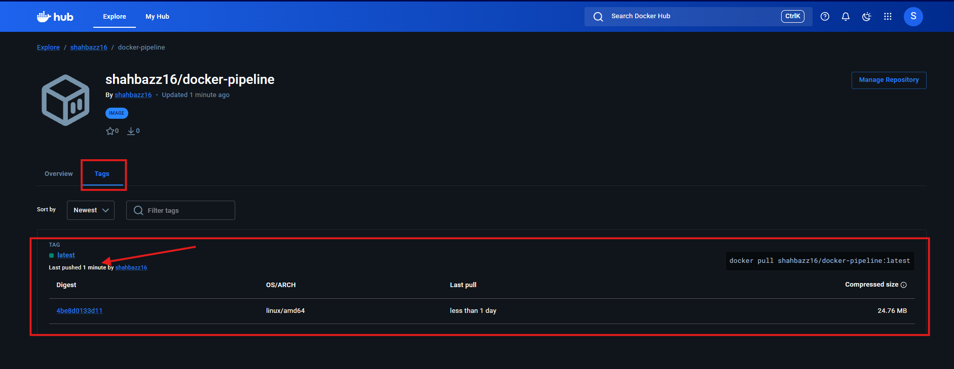

- shahbazz16/docker-pipeline:latest

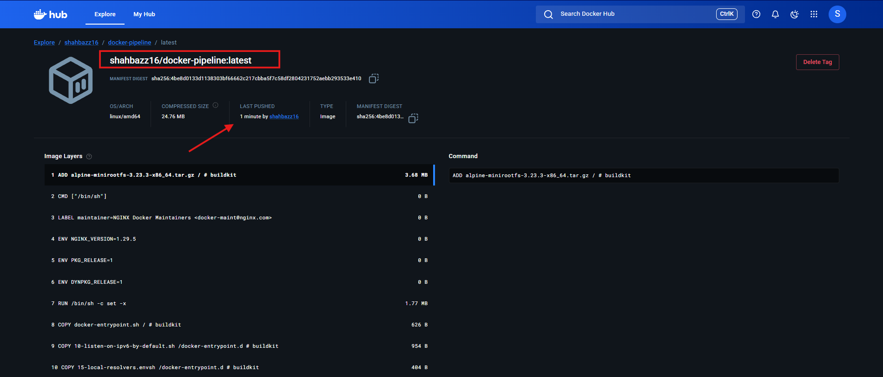

Validation: In cli in Jenkins server check for image we have pushed through pipeline
docker images

